**Description of the White River Partnership:**

The White River Partnership is an informal partnership of federal, state Tribal (eg Ute Tribe), Local and non-profit land and wildlife management entities, as well as private landowners, that are developing an ecological restoration plan for the riparian (riverside) vegetation of the White River from just east of Meeker, CO to the confluence with the Green River in Utah. Riparian vegetation is the vegetation that occurs alongside the river. The native riparian vegetation (like cottonwoods and willows) has been replaced by invasive trees (tamarisk and Russian olive) that reduce access to the river for recreation, reduce habitat for wildlife, and channelize the river, which reduces fish habitat.

Our goal as a partnership is to remove the tamarisk and Russian olive and replace them with native cottonwoods and willows to restore the health and natural function of the riparian area, and therefore the river.

Here is the webpage for the Partnership: <https://riversedgewest.org/white-river-partnership>

**The White River:**

In Colorado, the White River flows through agricultural and ranching lands, providing an important water source and grazing area for ranchers. In Utah, it flows through sandstone canyons. In spring/summer the White River is a brown-ish color due to sediment and runoff as seen in the photos, but summer-winter it becomes clearer.

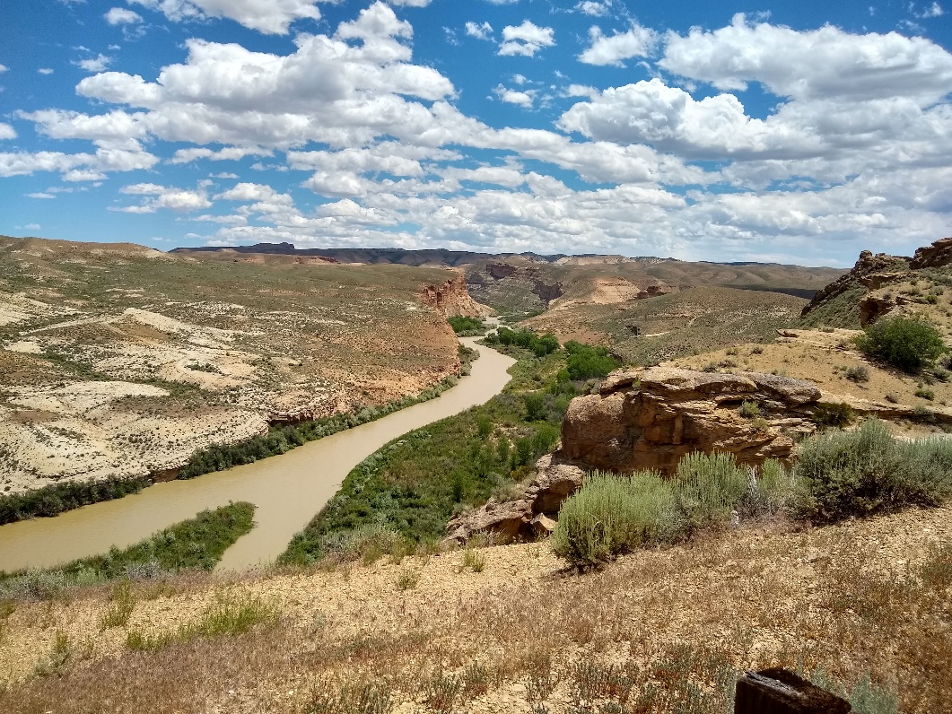

1The White River in Utah

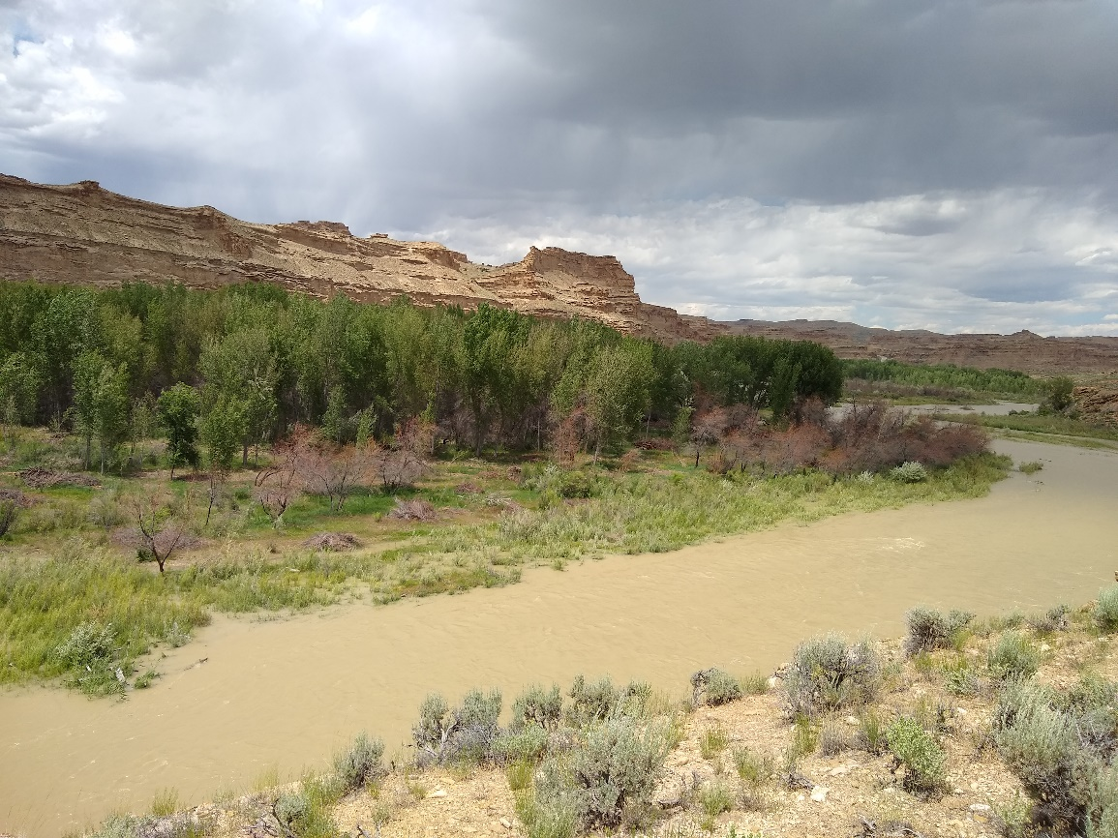

2The White River in Utah. The tall green trees on the far bank are desirable cottonwoods, the shorter, browner trees are the invasive tamarisk trees.

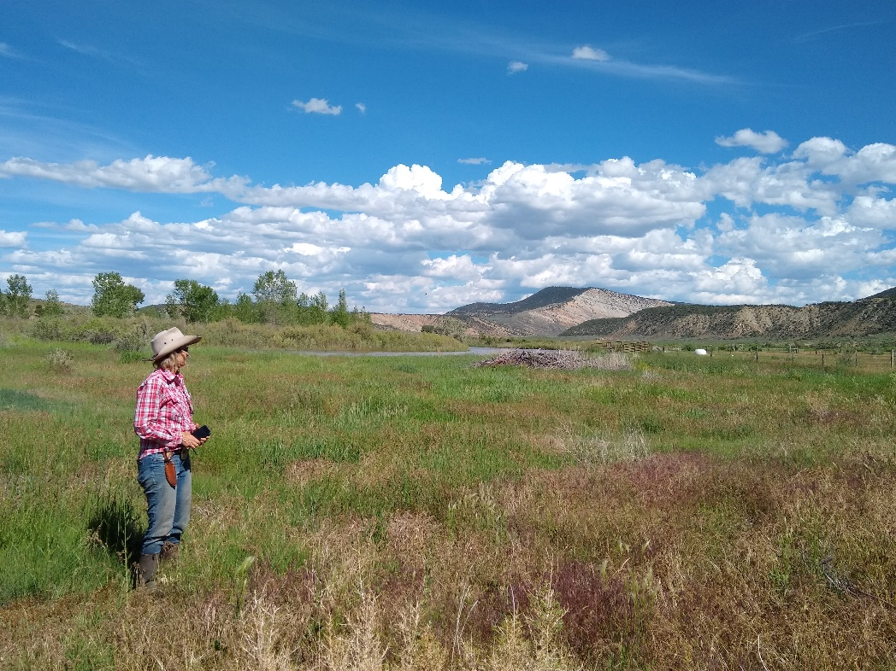

A ranch along the White River in Colorado

**Logo preferences:**

The logo will be used primarily for stickers, email headings, website headings, annual reports, occasionally for printed reports. Potentially may be used for larger posters.

We tend to prefer simpler designs, that prominently show the wording “White River Partnership”

It would be nice to include simple river/canyons/pasture field, and vegetation (that resembles native vegetation like cottonwoods and willows but does not resemble invasive vegetation like tamarisk or Russian olive).

Our mailing list currently uses the blue color below:

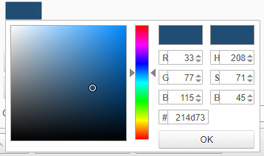

Here are some of example slides that we like from our work and from Ducimus’ examples:

